Feature vector

KNOWN FAULTS CLASSIFIER

REAL TIME ANOMALY DECTION

MONITORING AND FEATURE EXTRACTION

Normal state

WARNING MANAGEMENT

Warning

Machine &operator



Anomaly state

Unknown fault alarm

Full type alarm

Known

FAULT CLASSIFIER

Novel

ALARM MANAGEMENT

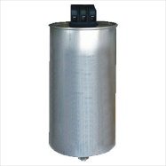 knowledge database